**CASE STUDY**

Submitted by

121810313024 KAMISETTY VENKATA HARSHITH

Under the Supervision of

Mr.S.Amarnadh

Asst.Professor

**Department of I.T,**

**GITAM INSTITUTE OF TECHNOLOGY, GITAM**



**DEPARTMENT OF COMPUTER SCIENCE AND ENGINEERING**

**GITAM INSTITUTE OF TECHNOLOGY**

**GITAM**

**(DEEMED TO BE UNIVERISTY)**

**VISAKHAPATNAM**

**(2018-19)**

**Pg.No:1**

**INTRODUCTION**

This Case Study is about a program which is used to make an arcade video game. The game is made using Turbo C++ . Here the drawing of the images and movement of image are done by using graphics function. The images are pasted on output screen by using predefined functions present in Turbo C++.The game shows user controls how to play. The name of the game is "Bounce Ball". The game consits of a ball and rectangle bat The objective of **game** is to keep the bouncing ball off the ground using a bat. In this **ball game,** players should remember that the further the ball is hit from the center of the racket, the further the ball bounces from the center of the racket. Players use the arrow keys to control the racket. The introduction to the game includes instructions on playing the game&by pressing space bar game will run. If we score 5 points level of the game increases and ball speed to increases This game improves our estimation skills. This game is very useful to us in our daily life , as we can play at any time it gives relief to our brain after hours of work .The main moto of this game is to help people analyze things better and quicker.

We can exit the game any time by pressing esc key.

**Pg.No:2**

**CONCEPTS USED**

* **Concept Name:**
* 1.while loop
* 2.if Condition
* 3.if -else Condition
* 4.Graphics Fuctions
* 5.Colour Function
* 6.exit Function
* 7.break Function
* 8.sound Function
* 9.Outtextxy Function
* 10.itoa Function
* 11.delay Function
* **Definition:**

**1.while loop :** While loop is an entry control loop which is used to execute a block of statements multiple no. of times basing on the requirement.

**2.if condition :** if statement is a conditional statement used to control flow of program basing the requirement.

**3.if-else condition :** if-else is a conditional statement which executes two different blocks basing on single condition i.e. if the condition satisfy ,then it executes first block and if the condition fails ,it executes second block.

**4.Graphics Functions:** graphics.h library is used to include and facilitate graphical operations in program. graphics.h functions can be used to draw different shapes, display text in different fonts, change colors and many more. Using functions of graphics.h you can make graphics programs, animations, projects and games

Ex: initgraph()

initgraph is used to initliaze the graphics system.

initgraph() loads the graphic driver(gd),after allocating memory for it,then puts the system in graphics mode(gm).

If “gdriver” is set to DETECT(auto detection).It calls detectgraph() and automatically selects the highest resolution graphics mode for “gmode”

The “&” symbol is used for initgraph to pass address of the constants.

**5.Colour function :** colour function is of 2 types which is used to give to a colour

**a).textcolor**

**b).setcolour**

**a).textcolor:**which is used to give a colour to specific text.

**b).setcolour:**it is a predefined function in the header file<#includegraphics.h> which is used to set colour to graphics.

**Pg.No:3**

**6.exit function :** the **exit** function calls all functions registered with atexit and terminates the program.

**7.break statement:** it is a predefined statement, as it is used to exit the current loop

**8.sound function:** Sound function produces the sound of a specified frequency. Used for adding music to a C program

**9.outtextxy function:** outtextxy function in c. outtextxy function display text

or string at a specified point(x,y) on the screen.

**10.itoa function:** itoa function converts integer into null-terminated string. It can convert negative numbers too.

**11.delay function :** delay function is used to suspend execution of a program for a particular time.

**Pg.No:4**

* **Syntax:**

**1.while loop:**

<initialization>;

while(<condition>)

{

Statement 1;

Statement 2;

<updation>;

}

**2.if condition:**

if(<Condition >)

{

Statement 1;

Statement 2;

}

**3.if-else condition:**

if(<Condition >)

{

Statement 1;

Statement 2;

}

else

{

Statement 1;

Statement 2;

}

**4.Graphics Functions:**

**initgraph() syntax:**

int gd=DETECT,gm;

initgraph(&gd,&gm,”C:\\tc\\bgi”);

“C:\\tc\\bgi” specifies the directory path.

rectangle(x1,y1,x2,y2);

where, (x1,y1) is the initial diagonal point. (x2,y2) is the final opp diagonal point.

circle(x,y,radius);

where (x,y) is the centre of the circle.

**Pg.No:5**

**5.colour function:**

**a)** setcolor(colorname)

**b).**getcolour(colourname)

**6.exit function:**

(exit(0)or exit(EXIT_SUCCESS)) or(exit(non-zero)or exit(EXIT_FAILURE) )

**7.break statement:**

break;

**8.sound function:**

**a).for sound:**sound()

**b) to stop sound:**nosound()

**9.ottextxy function:**

outtextxy(int x, int y, char *string); x, y are coordinates of the point and 3rd is

address of a string or we can even print a string by giving it in a “ “

**10.itoa function:**

 char * itoa( int num, char * buffer, int base)

**11 .delay function:**

void delay(unsigned int);

**Pg.No:6**

**source code:**

#include<stdio.h>

#include<conio.h>

#include<graphics.h>

#include<stdlib.h>

#include<dos.h>

int main()

{

int gd = DETECT, gm;

int i=16,j=16,i_incr,j_incr;

int scr_x,scr_y;

int rect_x,rect_y;

char c;

int k,n=0,level;

char a[10],b[10];

textcolor(RED);

cprintf("welcome to the bounce ball game");

cprintf("\nINSTRUCTIONS");

printf("\nuse left arrow to move the bar towards left");

printf("\nuse right arrow to move the bar towards right");

printf("\npress space bar to start the game");

cprintf("\npress esc button to escape the game");

c=getch();

if(c==32)

{initgraph(&gd,&gm,"c:\\TURBOC3\\BGI");

setcolor(YELLOW);

scr_x=getmaxx()-15;

scr_y=getmaxy()-15;

i_incr=1;

j_incr=2;

rect_x=getmaxx()/2-20;

rect_y=getmaxy()-5;

while(1)

{

i=i+i_incr;

j=j+j_incr;

if(i>=scr_x||i<=15)

{

i_incr=i_incr*-1;

sound(1000);

nosound();

}

if(j>=scr_y||j<=15)

**Pg.No:7**

{

j_incr=j_incr*-1;

if(j>=scr_y)

{

if(i<rect_x || i>rect_x+50)

{ printf("game over");

printf("\nscore is %d",n);

getch();

break;

}else{n=n+1;}

}

sound(1000);

nosound();

}if(n>=0&&n<=5)

{

delay(40);

level=1;}

if(n>=6&&n<=10)

{

delay(30);

level=2;

}if(n>=11&&n<=15)

{

delay(15);

level=3;

}

if(n>=16&&n<=20)

{

delay(5);

level=4;

}

cleardevice();

circle(i,j,15);

if(kbhit())

{

c=getch();

if(c==75)

{

if(rect_x>=0)

{

rect_x=rect_x-10;

}

}

else if(c==77)

{

if(rect_x<=scr_x-50)

{

rect_x=rect_x+10;

**Pg.No:8**

}

}

else if(c==27)

{

break;

}itoa(n,a,10);

outtextxy(500,20,"score:");

outtextxy(550,20,a);

itoa(level,b,10);

outtextxy(500,40,"level:");

outtextxy(550,40,b);

}

rectangle(rect_x,rect_y,rect_x+50,getmaxy());

}exit(0);

closegraph();

}

return 0;

}

**Pg.No:9**

**Output Screen Shots :**

**Output 1:**

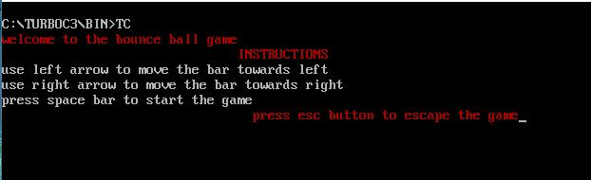

**Output2:**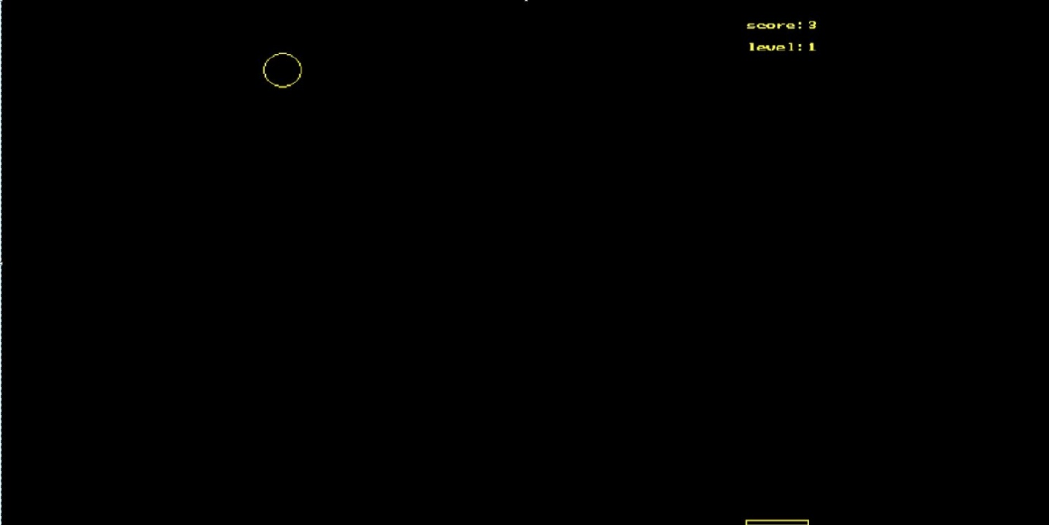

**Pg.No:10**

**output3: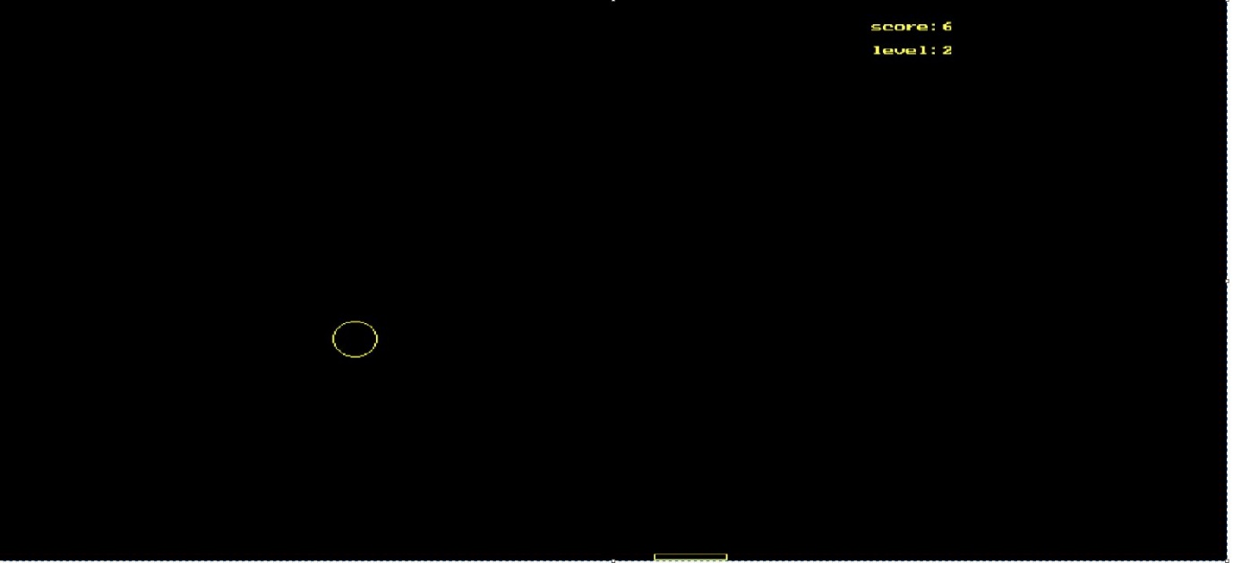output4:**